Use Case Diagram

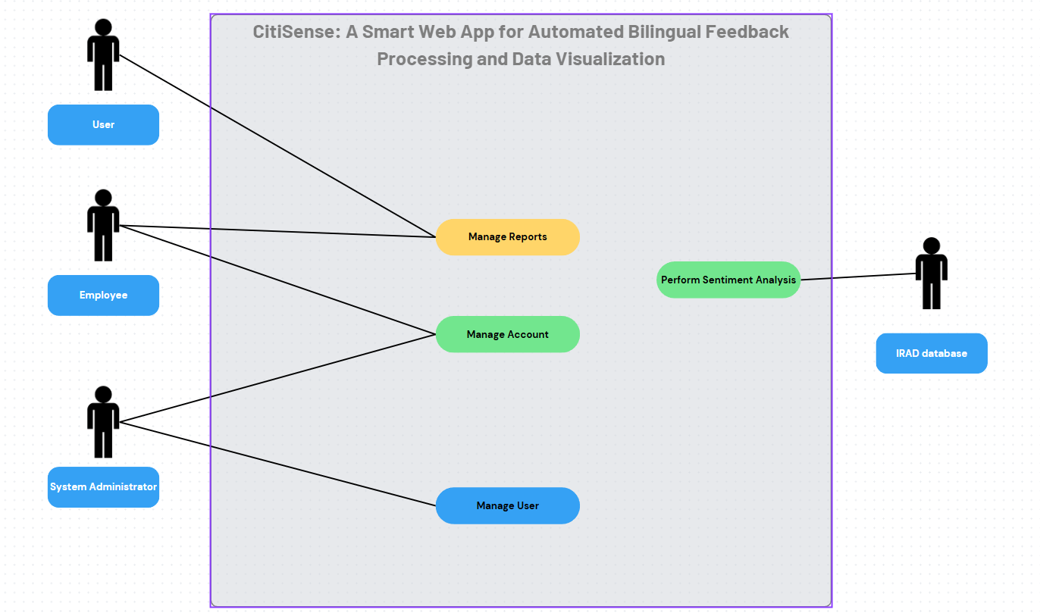

Level 0 (Context Diagram)

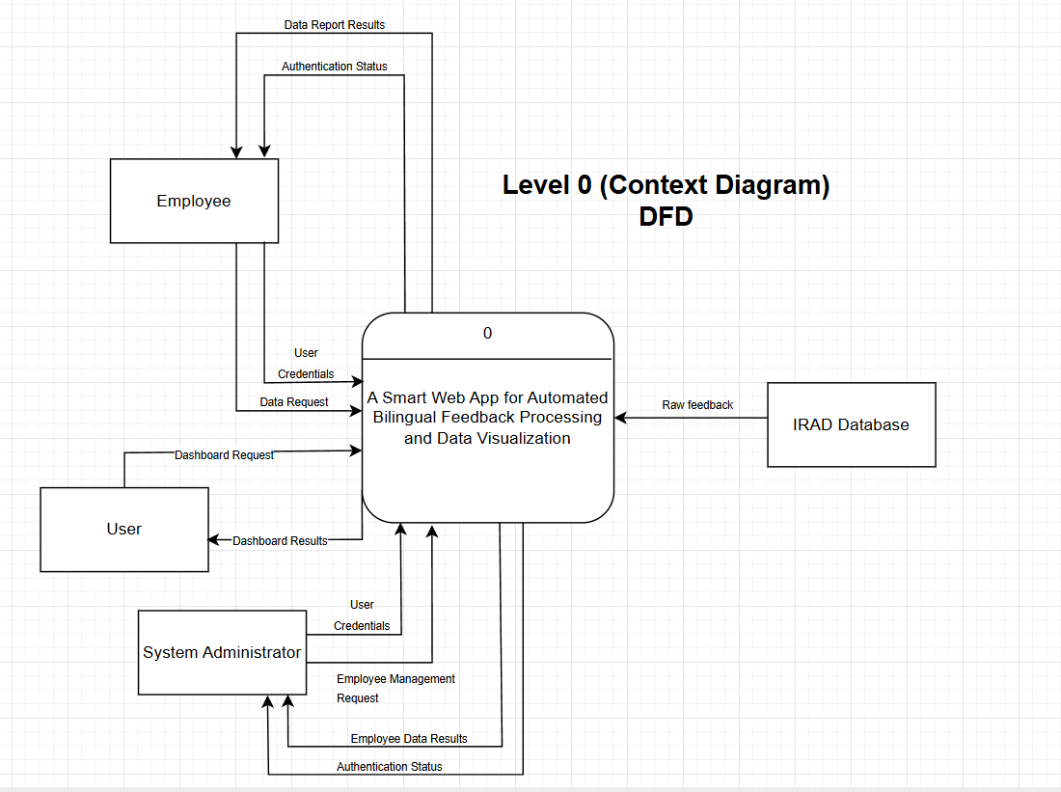

Level 1 DFD

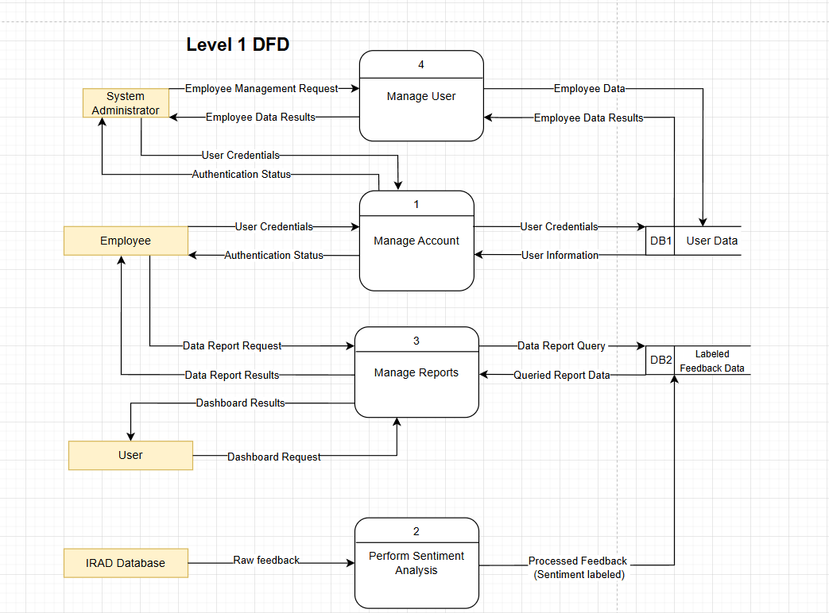

Level 2 – 1.0 Manage Account

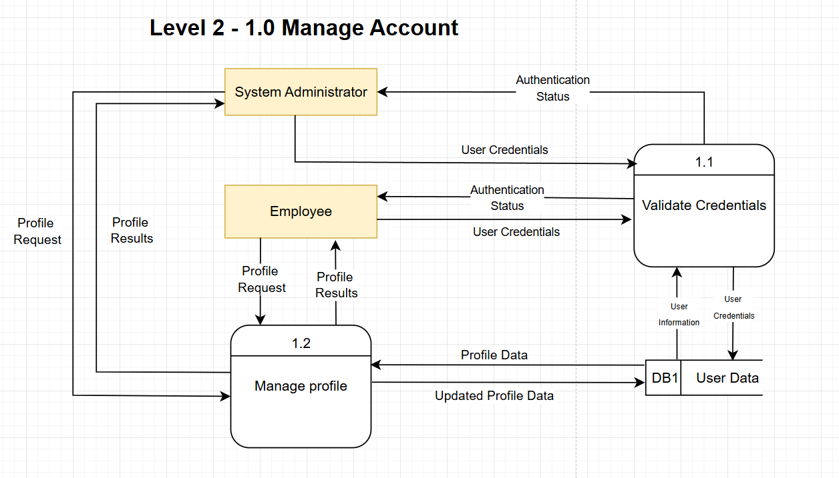

Level 2 – 2.0 Perform Sentiment Analysis

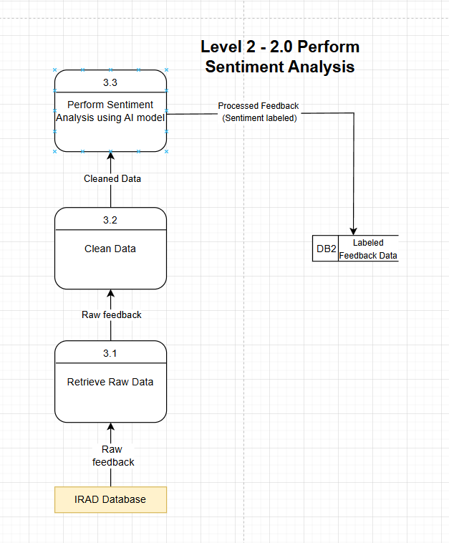

Level 2 – 3.0 Manage Reports

